Nama : Dwi Febi Fauzi

NIM : 18090125

Kelas : 5C

1. URL : <http://localhost/ci_fauzi/index.php/Matakuliah>
2. Source Code

* application 🡪 controller 🡪 Matakuliah.php

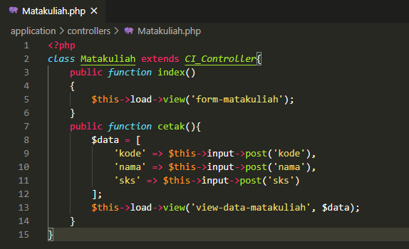

* application 🡪 views 🡪 form-matakuliah.php

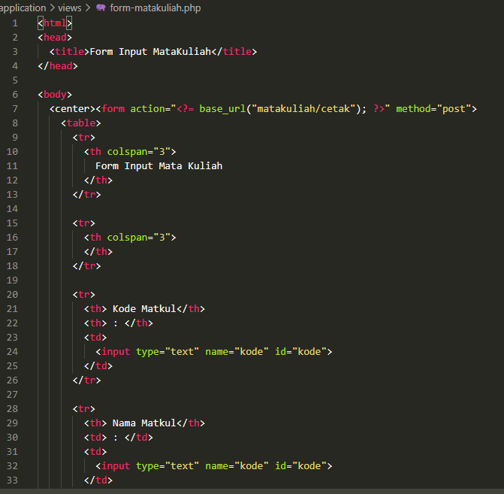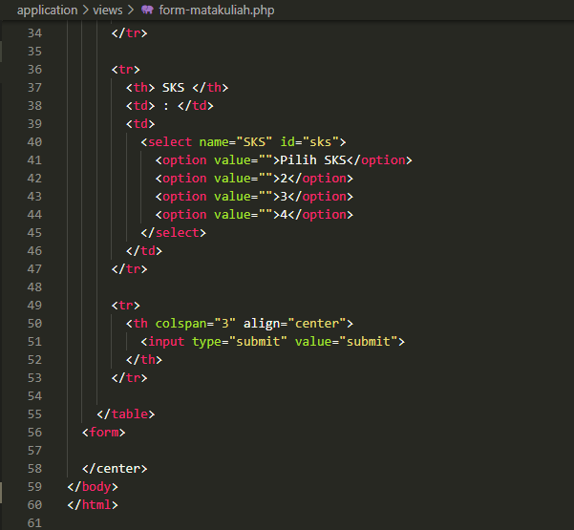

* application 🡪 views 🡪 view-data-matakuliah.php

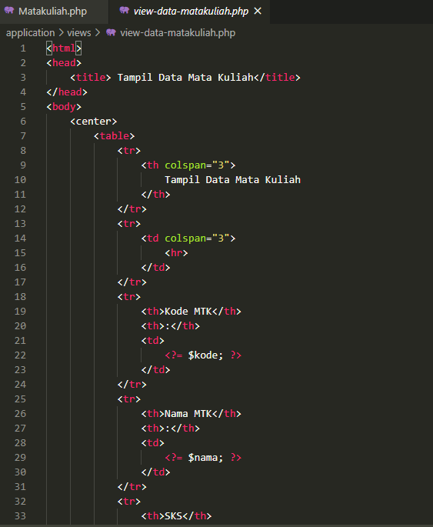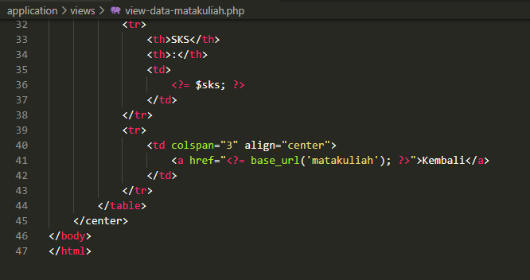

1. Screen Shoot

